LIBRARY MANAGEMENT SYSTEM

***INDEX***

|  |  |  |
| --- | --- | --- |
| *SNO* | *TOPIC* | *PAGE NO* |
| *1* | *INTRODUCTION* | *2* |
| *2* | *ARCHITECTURE* | *3* |
| *3* | *MODULES* | *5* |
| *4* | *IMPLEMENTATION* | *6* |
| *5* | *SALIENT FEATURES* | *10* |
| *6* | *FUTURE ENHANCEMENTS* | *11* |
| *7* | *CONCLUSION* | *12* |
| *8* | *REFERENCES* | *13* |

***INTRODUCTION***

Libraries are an essential part of student lives and managing them becomes a tiresome task for the librarian. Our project aims to reduce the workload of the librarian and increase efficiency by digitalizing the process of issuing and returning books.

The Library Management System is an application for assisting a librarian in managing a library. The system would provide basic set of features to add/update members, add/update books, and a few features such as buying books and search books.

A defining feature of our project is the “Open Library” concept, where students don’t need to register and the details of the students are not known by the librarian except the id which is assigned by the school. This concept reduces the storage space and reduces redundancy in the database maintained by the school. It also reduces the workload of the librarian, and the process of borrowing books is easier than traditional libraries.

The other distinct feature is the option to buy books. The librarian can easily navigate to the store page just by giving the name of the book and submitting. It

redirects them to amazon’s product page with the book. This is useful in situations when the librarian is not accustomed to online shopping in which case this is setup to provide ease of access.

With these features in our mind, we planned our project and decided to split the workload among us and develop the project as a learning exercise. We used the waterfall model to plan our project’s lifecycle and with pre-planned targets we began developing the project. Finally, we put the project under rigorous testing to check for errors and debugged them, and documentation for the project, which describes the features and modules, was prepared which is the following document.

***ARCHITECTURE***

We have used ER-diagram to show the various modules we used and their relationships. Given below is the snapshot of the ER-diagram.

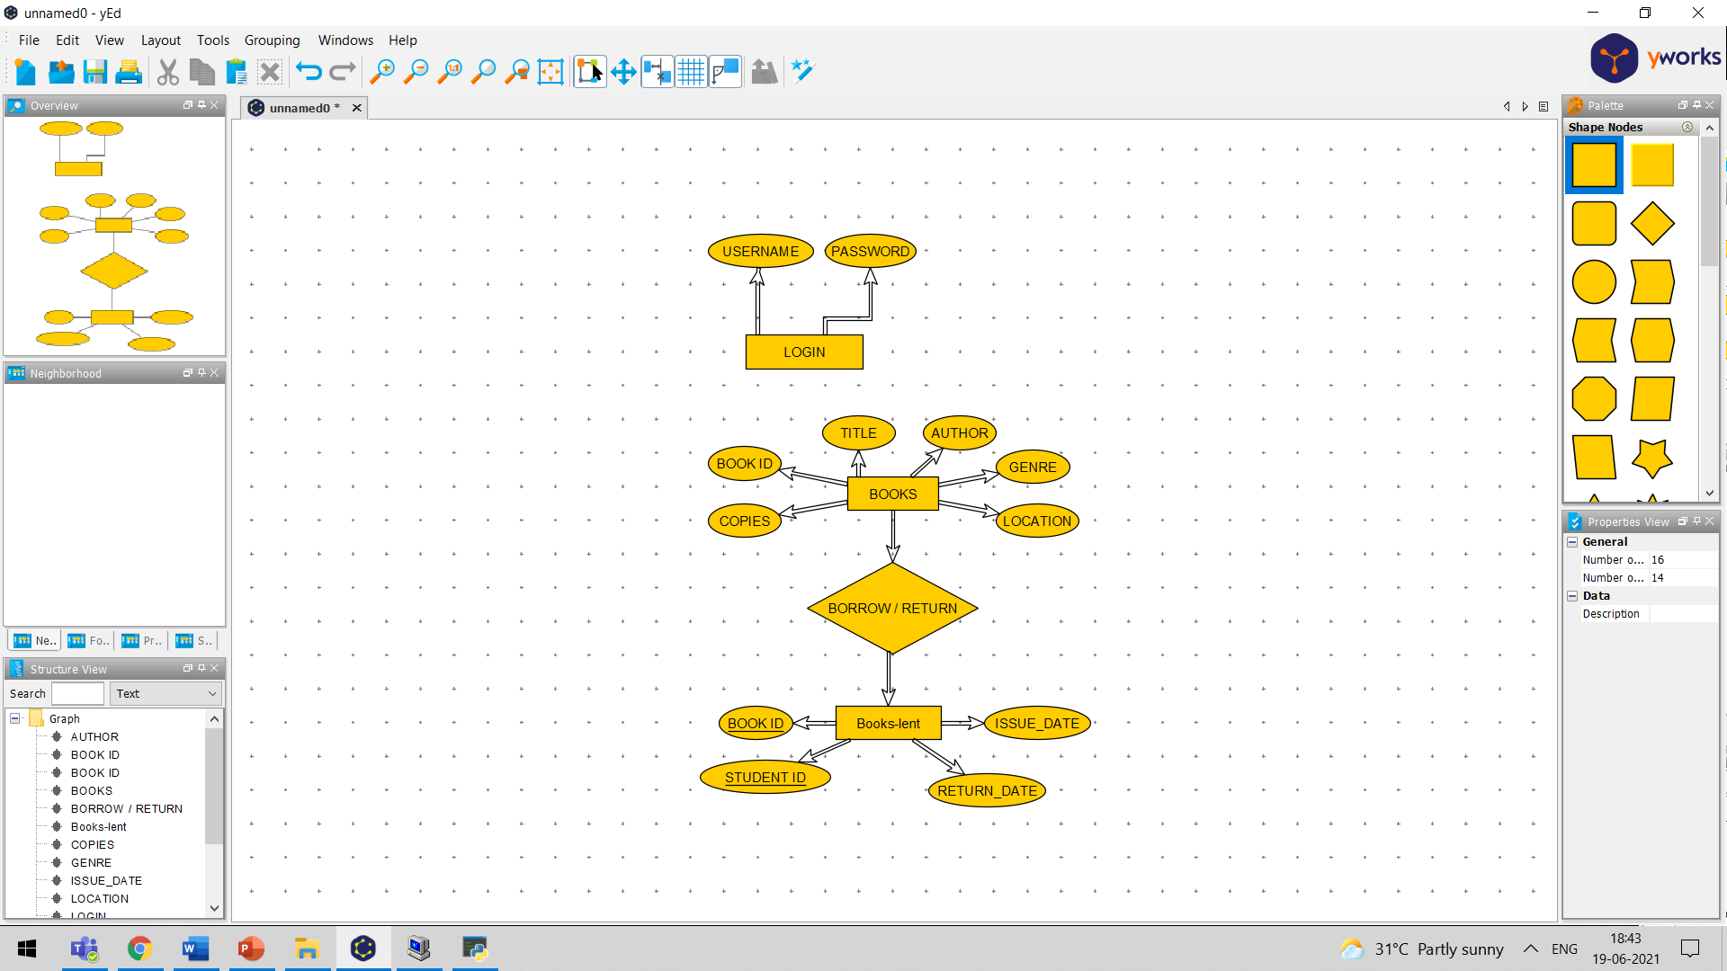

As we see in the image above there are 3 tables with only 2 major tables for ease of access. Now let us understand the purpose of the tables created.

* **Login table-**

This is a simple table used to hold the values for login details that is the username and password. It has only 1 major module which checks if the user input password and username match with the details stored in our Database.

* **Books table-**

This table stores the data of the books in the library such as id, title, author name, number of copies, genre and physical location of the book.

It has multiple modules which we’ll look into in the modules section in detail.

* **Book-lend table-**

This table stores the data of the books that are being lent out to the students in the library such as book id, student id, issue date and return date. It has multiple modules which we’ll look into in the modules section in detail.

These are the tables that we have used in the project which are given below:

**LOGIN:**

|  |  |
| --- | --- |
| Username | Password |
| Admin | 123 |
| Principal | 123 |

**BOOKS:**

|  |  |  |  |  |  |
| --- | --- | --- | --- | --- | --- |
| Book ID | Title | Author | Genre | Copies | Location |
| 1 | Harry Potter | JK Rowling | Fantasy | 2 | A1 |
| 2 | Oxford | Wren | Academic | 1 | B0 |

**Books lent:**

|  |  |  |  |
| --- | --- | --- | --- |
| Book ID | Student ID | Issue Date | Return Date |
| 1 | 101 | 15-06-2021 | 30-06-2021 |
| 2 | 102 | 12-06-2021 | 05-07-2021 |

***Modules & a brief explanation of their use***

We have used modularity as a core concept of our project now we’ll look into the modules we have used in the project and their uses.

* ADD_BOOK: This module is used to add new books to the table Books by accepting user input and committing them to the table, it also checks if the book is already present if so, it throws an error.
* SEARCH_BOOK: This module looks for the record which has any of the input from the user and displays it. This also invokes the other module UPDATE which is used to update the data of the book.
* UPDATE_BOOK: This module uses the results fetched by the SEARCH_BOOK module and gives the user 3 options add number of copies delete number of copies and delete all copies.
* BUY_BOOK: This module uses webbrowser module of Python to redirect the user to amazon product page of the user input book.
* ISSUE_BOOK: This module accepts the book id and student id and deducts number of copies in book table by 1 and creates a new record in book-lent table.
* RETURN_BOOK: This module accepts the book id and student id and increases the number of copies in book table by 1 and deletes record in book-lent table.
* VIEW_BOOK: This module displays the book-lent table so the user can identify defaulter records and have a control over the overall books lent.

Various other minor modules were used for aesthetic effect but these were the major modules that alter the database. Now we will look into their workings in the upcoming pages as screenshots of the application at work.

***Working of the Modules***

**ADD_BOOK-**

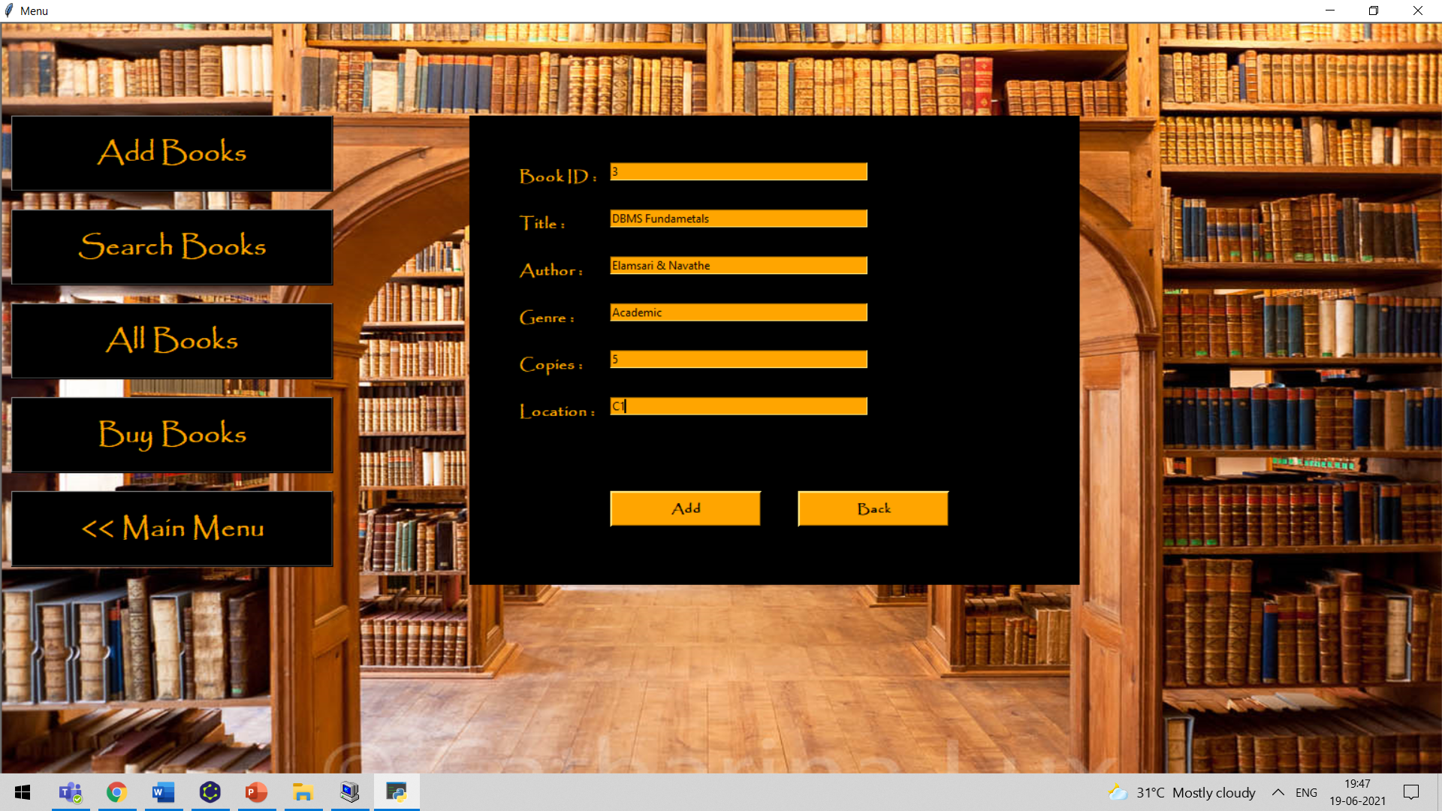

**SEARCH_BOOK-**

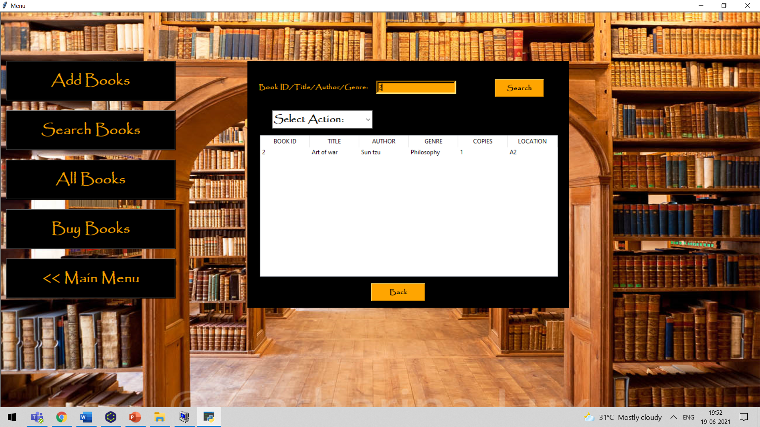

**VIEW_ALLBOOK-**

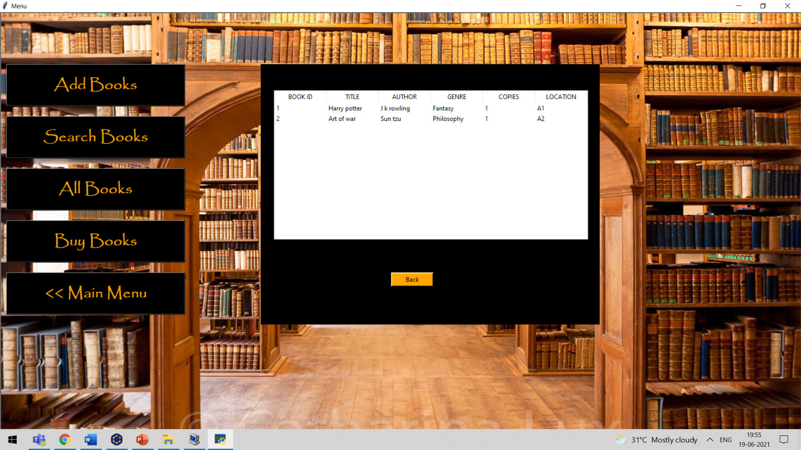

**ISSUE_BOOK-**

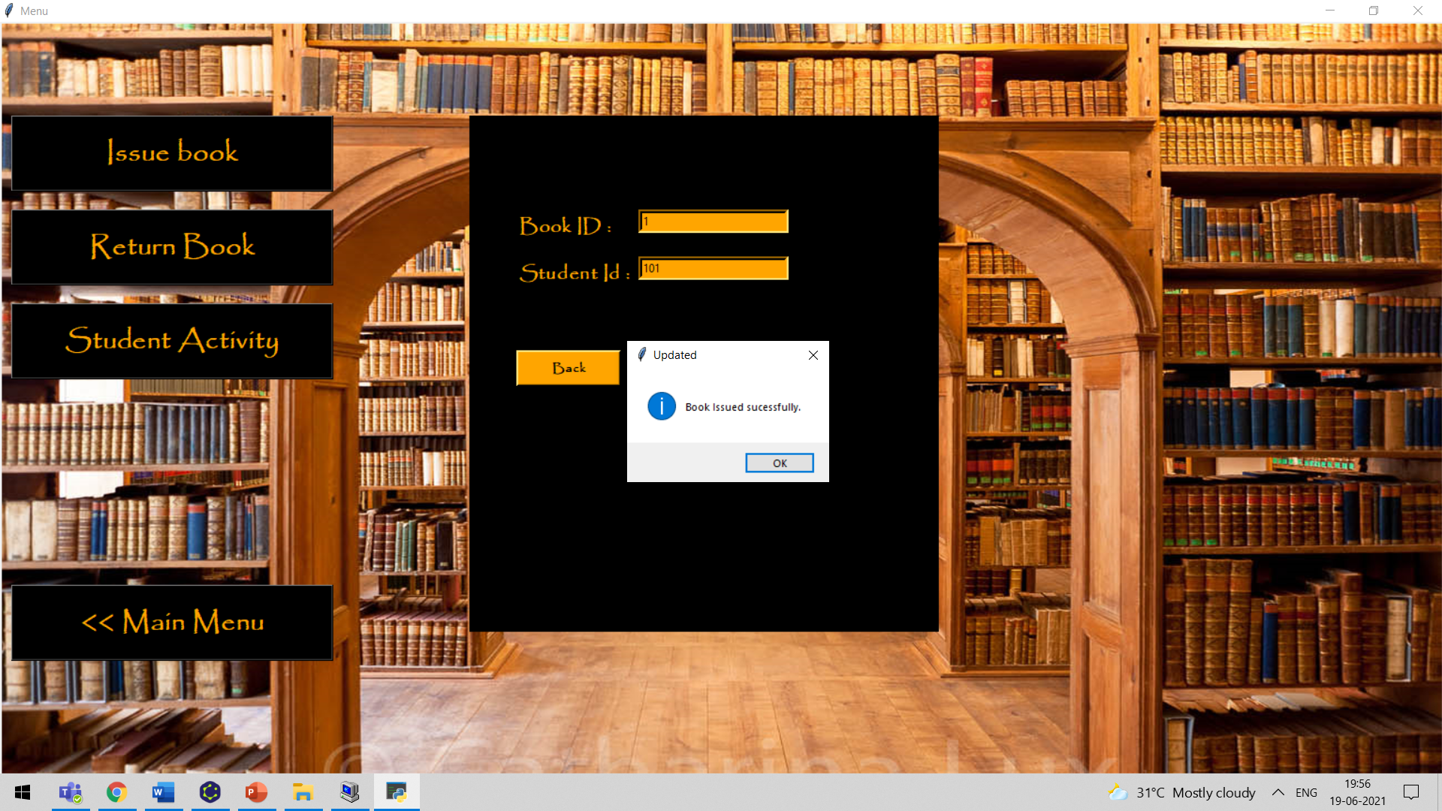

**VIEW_BOOK-**

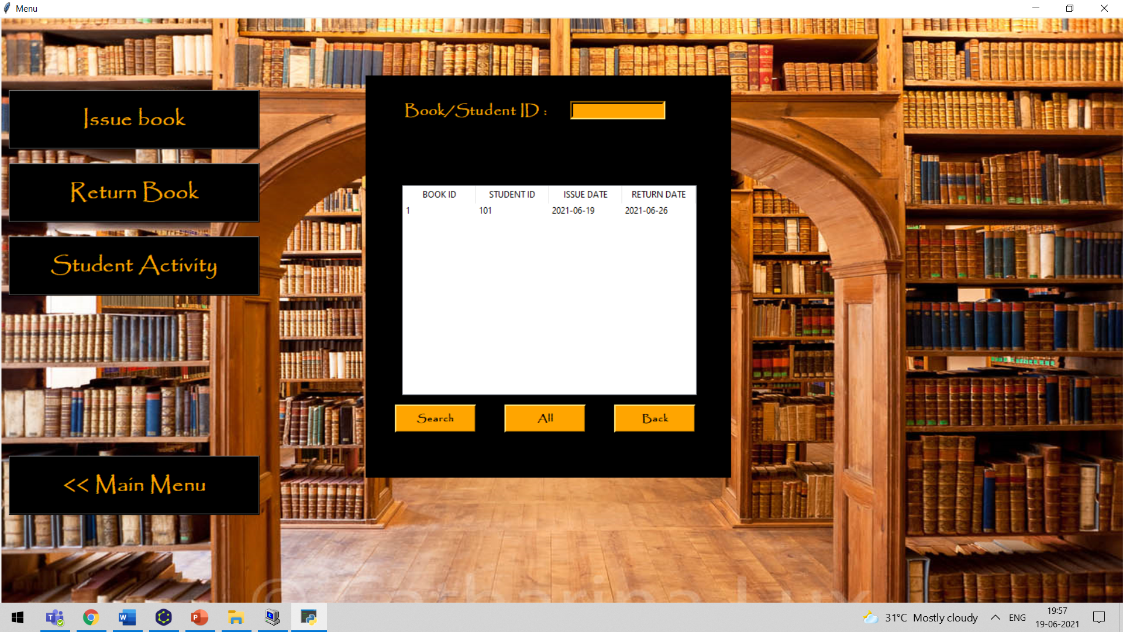

**RETURN_BOOK-**

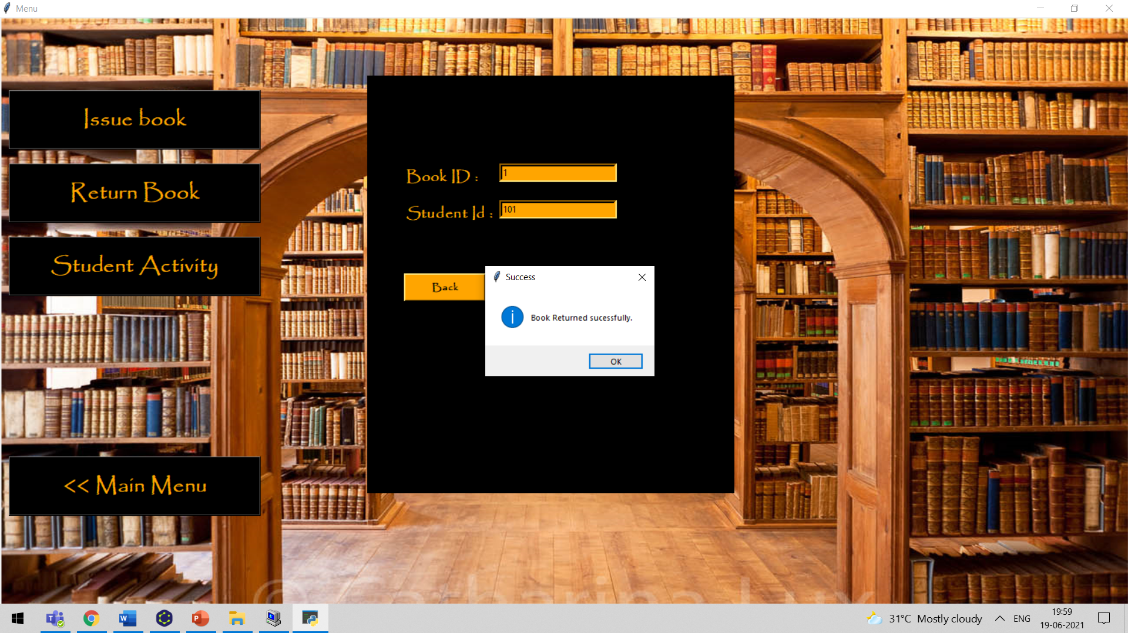

**UPDATE_BOOK-**

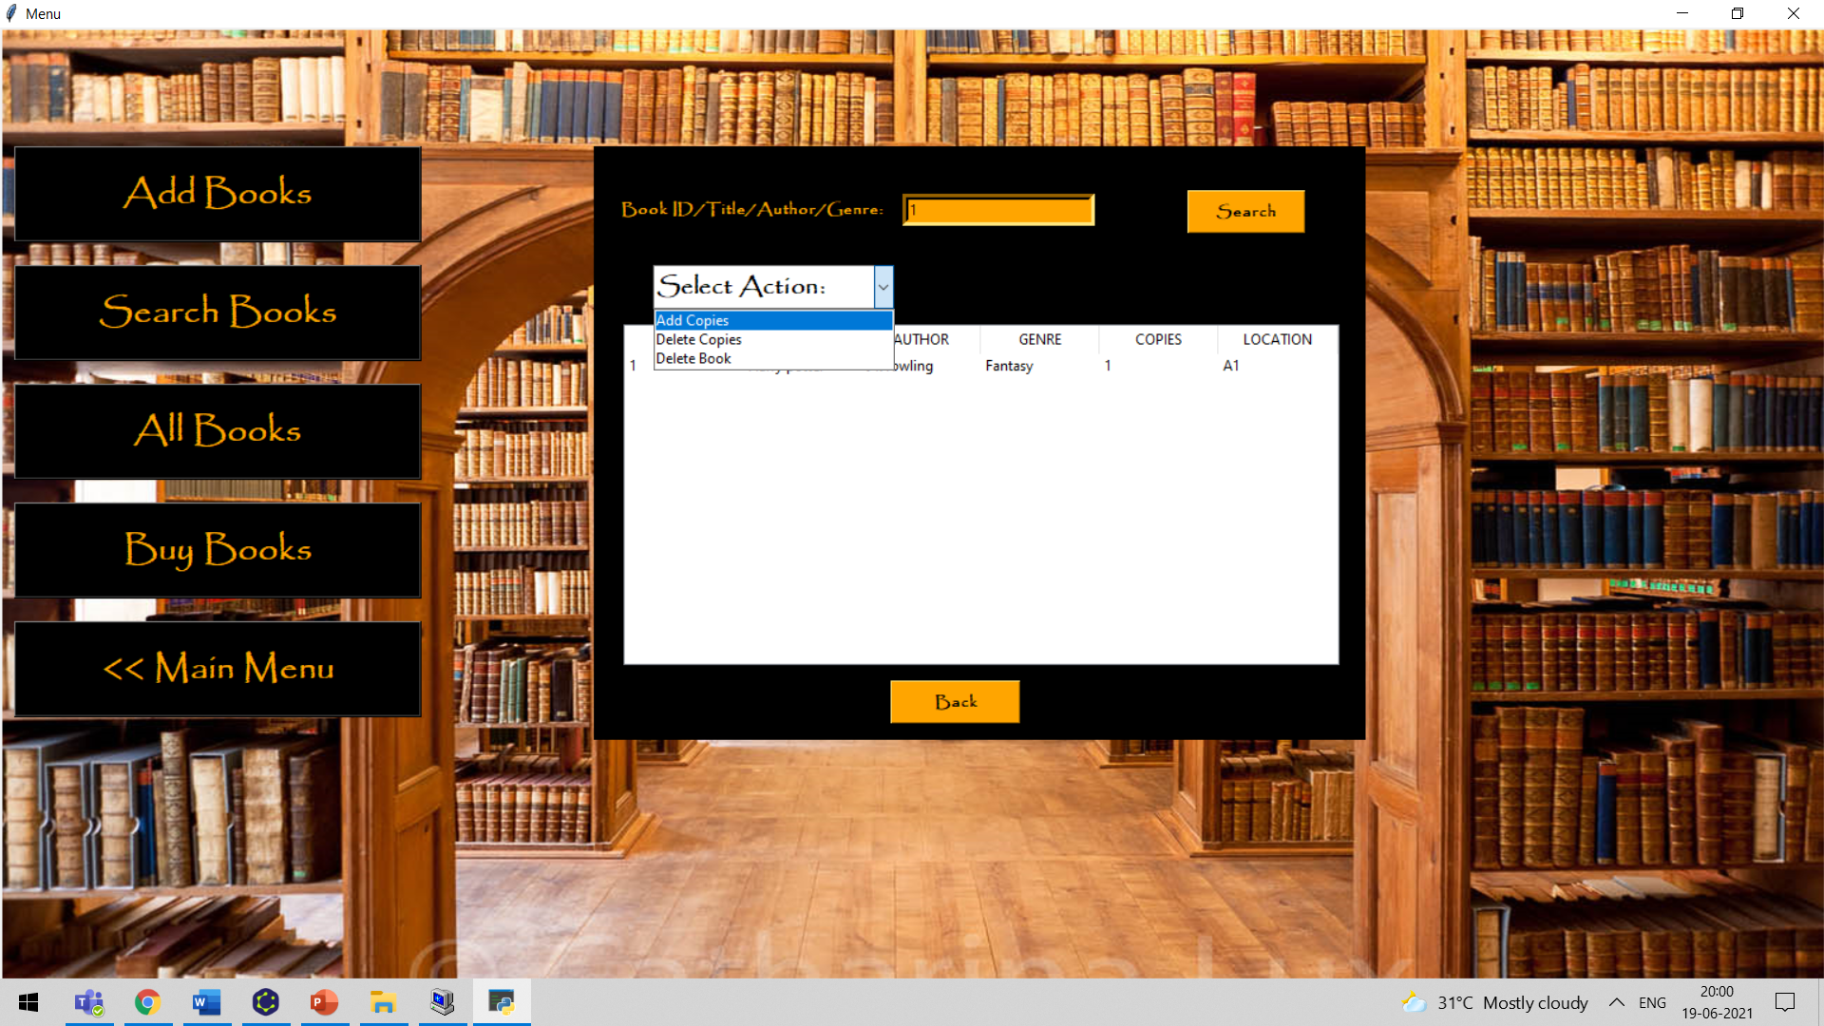

**BUY_BOOK-**

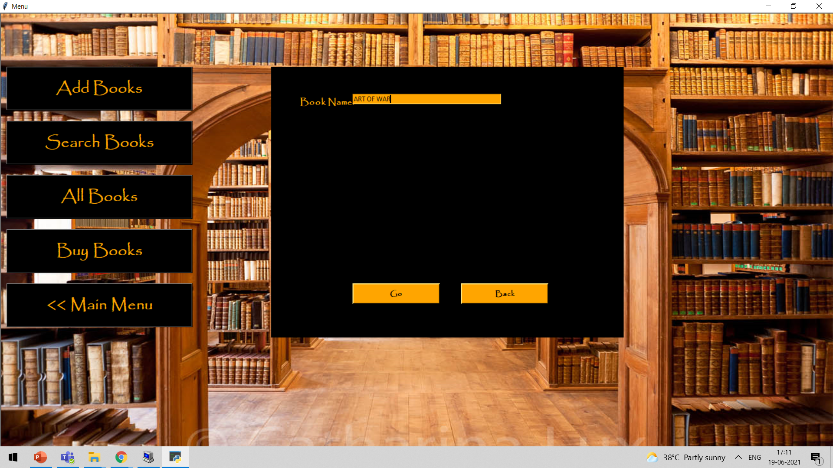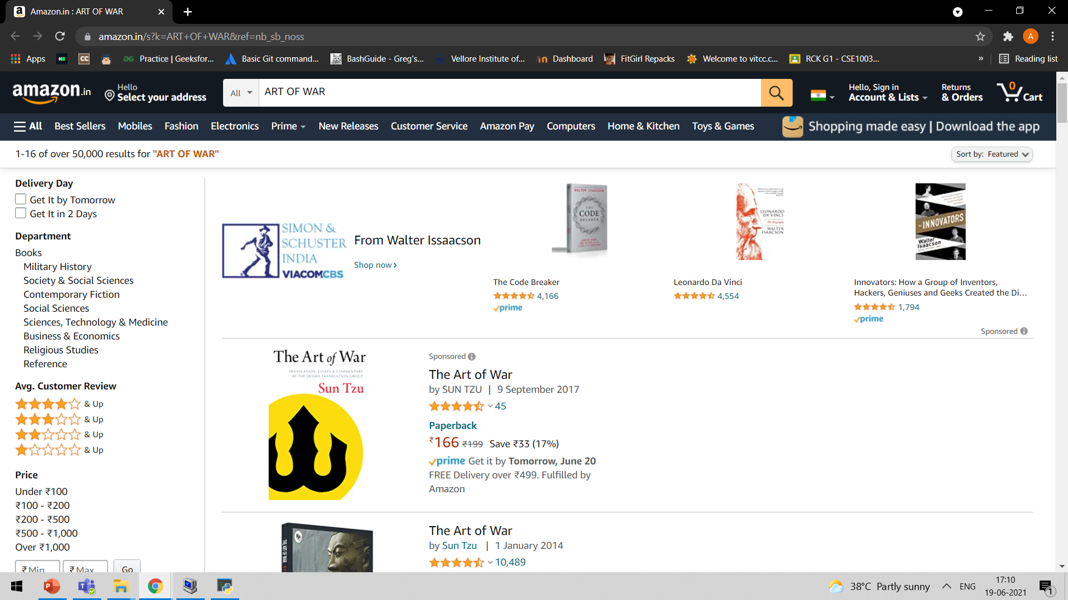

These are a few of the screenshots of the modules in work, other screenshots can be viewed in the screenshots folder.

***SALIENT FEATURES***

* **Temporary Logs:** A temporary log of all the menus visited and changes made to the database is made available in the interpreter. A permanent log, i.e. log file was planned to be used but storage issues might build up so we used a temporary log method.
* **Checks:** Various checks were put in place to ensure data consistency and reduce redundancy including distinct book id and checking if no of copies is positive
* **Complete** **Control over tables:** The tables were created and modules were made to ensure the admin has complete access over the tables and can be viewed anytime in tabular form.
* **Buying books:** The admin can purchase books with the push of a button where they’ll be re-directed to the product’s amazon page, after purchase the ADD_BOOKS module will be invoked so the books can be added easily.

These are some of the features that our system offers, which other library management systems don’t offer. These features combined with the “open library” model differentiate our project from other similar projects.

***FUTURE ENHACEMENTS:***

A good project is known by its ability to rapidly adapt to the changing times and as such ensuring provisions for the same becomes a matter of utmost importance. So, our project has been carefully been spilt into modules with various comments describing the uses of the modules.

We had a few ideas that we couldn’t implement due to time constraint. The BUY_BOOK module can be extended to show suggestions to the user on which books to purchase which can be implemented by using beautifulsoup module in python to scrape data off amazon’s API which we couldn’t implement as we had to go through the documentation of the API to implement it.

***CONCLUSION:***

The goals of our project were achieved within the stipulated time which was made possible by excellent teamwork and coordination by the team members.

This has been a great hands-on learning opportunity for us and introduced us to the lifecycle of software development and complexities of Database Management Systems.

Even though COVID had an impact on the project and caused delays we were able to complete the project and the documentation. We thank VIT for giving us the opportunity to implement and display our project.

***References:***

* <https://docs.python.org/3/>
* <https://www.tutorialspoint.com/sqlite/sqlite_python.htm>
* <https://realpython.com/beautiful-soup-web-scraper-python/>
* <https://www.geeksforgeeks.org/sql-using-python/>
* <https://www.tutorialspoint.com/sdlc/sdlc_waterfall_model.htm>
* <https://www.datacamp.com/community/tutorials/gui-tkinter-python>

